**Assignment no-2**

Ans1) Difference between UI and UX

* **UI**-

It stands for user interface.

It refers to the visual elements that allow users interact

With a product.

It focuses on the look of color ,images and text fonts etc.

It’s goal is to make product more an usable and

Optimized for different screen sizes.

* **UX-**

It stands for user experience.

It is about feelings and emotions user experience when

Interacting with a product.

It focuses on the overall user-friendliness of the user

Journey.

It’s goal is to delight users with a product that is efficient

And easy to use.

Ans 2) -

**Frontend developer-**

Frontend developer is responsible to create an entire design like front page ,text ,images buttons and other features.the front developer is not concerned with a server side.the frontend developer works as client side which is visible to user.as soon as we open the website,the design that we see,that the design is open in a good-looking format,this is the work of frontend developer.

mainly , the role of frontend developer is conversion of a pdf file into HTML file.

It works on HTML,CSS and some frameworks(react.js).

Ans 3)-

**Backend developer-**

Backend developer works as the backend of websites is a combination of servers,applications and database.Backend developer is also known as server side development.

It works on the logic of the server behind the websites.It also customizes the code.Suppose we are running the query from a database,then in that case,our data should be customized.

Whenever a dynamic website is created,the role of its backend developer will come because without database and server side programming,we cannot create a dynamic website.

It works on PHP/Python/java/node.js,frameworks (ruby/danjo/ express.js) and database.

Ans 4)-

**Github profile-**

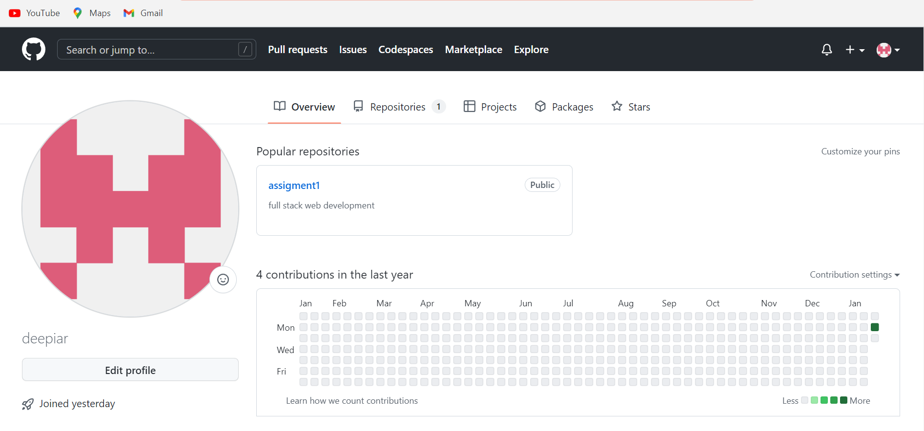

Link- <https://github.com/deepiar>

**Linkedin profile-**

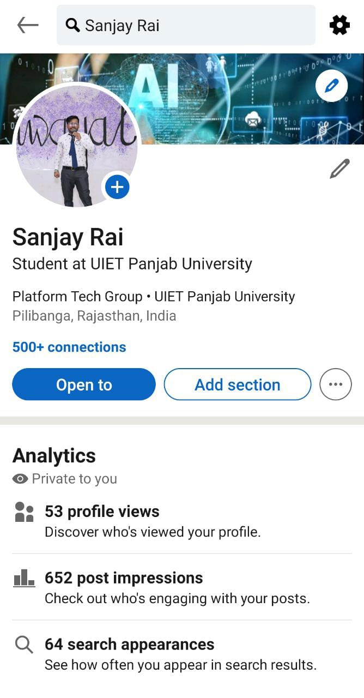

link-<https://www.linkedin.com/in/sanjay-rai-1491b4228>

Ans 5)-

Blog link-<https://hashnode.com/@Sanjhok>